Installed minikube and docker locally and checked the status

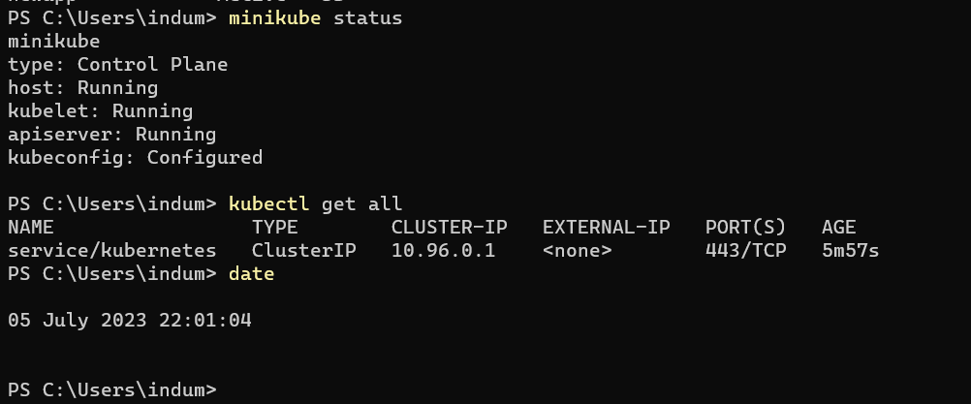

Creating Namespace and checking the list of NS and checking currently in which ns I am into.

